24.74: a) 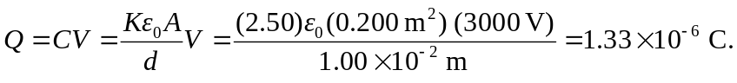
b)
c) 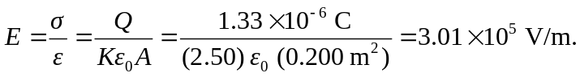
d) 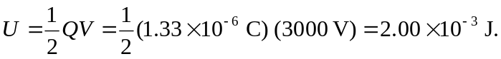
e) 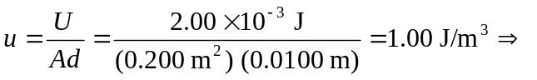or
f) In this case, one does work by pushing the slab into the capacitor since the constant potential requires more charges to be brought onto the plates. When the charge is kept constant, the field pulls the dielectric into the gap, with the field (or charges) doing the work.

